Host to Host Communication

Since there are no Routers in this illustration, we know all the communication is happening within the same network — therefore, Host A and Host B are both configured with IP addresses that belong to the same network.

[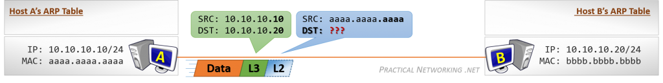](http://www.practicalnetworking.net/wp-content/uploads/2016/01/packtrav-hth-1.png)

Each host has a unique IP address and MAC address. Since each host is also a [L3](http://www.practicalnetworking.net/series/packet-traveling/osi-model/#osi-layer-3) device, they each also have an [ARP Table](http://www.practicalnetworking.net/series/packet-traveling/key-players/#arp-table). At the moment, their ARP Tables are empty.

Host A starts by generating some Data for Host B. Host A knows the final destination for this data will be the IP address 10.10.10.20 (Host B). Host A also knows its own address (10.10.10.10), and as such is able to create a L3 header with the required Source and Destination IP Address.

But as we learned earlier, [packet delivery is the job of Layer 2](http://www.practicalnetworking.net/series/packet-traveling/osi-model/#osi-layer-23), so despite these hosts being directly connected to one another, a L2 header must be created.

The Source of the L2 header will be Host A’s MAC address (aaaa.aaaa.aaaa). The Destination of the L2 header *should* be Host B’s MAC address, but at the moment, Host A doesn’t have an entry in its ARP Table for Host B’s IP address, and therefore, does not know Host B’s MAC address.

As a result, Host A is unable to create the proper L2 header to deliver the packet to Host B’s NIC at this time. Host A will have to initiate an ARP Request in order to acquire the missing information:

[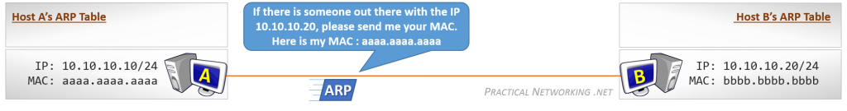](http://www.practicalnetworking.net/wp-content/uploads/2016/01/packtrav-hth-2.png)

The ARP Request is a single packet which essentially asks: “*If there is someone out there with the IP 10.10.10.20, please send me your MAC address.*”

Remember, at this point Host A does not know if Host B exists. In fact, Host A does not know that it is directly connected to Host B. Hence, the question is addressed to *everyone* on the link. The **ARP Request is sent as a Broadcast**, and had there been other hosts connected to this link, they too would have received the ARP Request.

Also note that Host A includes its own MAC address in the ARP Request itself. This allows Host B (if it exists) to easily respond directly back to Host A with the requested information.

[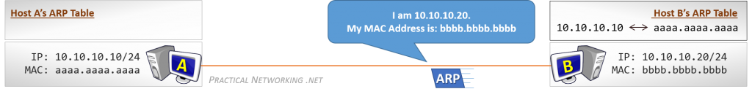](http://www.practicalnetworking.net/wp-content/uploads/2016/01/packtrav-hth-3.png)

Receiving the ARP Request allows Host B to learn something. Namely, that Host A’s IP address is 10.10.10.10 and the correlating MAC address is aaaa.aaaa.aaaa. Notice this entry is now added to Host B’s ARP Table.

Host B can use this new information to respond directly to Host A. The **ARP Response is sent as a Unicast**message, directly addressed to Host A. Had there been other hosts on this link, they would *not* have seen the ARP Response.

The ARP Response will include the information Host A requested: The IP Address 10.10.10.20 is being served by the NIC with the MAC address bbbb.bbbb.bbbb. Host A will use this information to populate its ARP Table:

[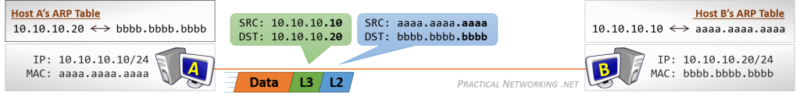](http://www.practicalnetworking.net/wp-content/uploads/2016/01/packtrav-hth-4.png)

With Host A’s ARP Table populated, Host A can now successfully put together the proper L2 header to get the packet to Host B.

When Host B gets the data, it will be able to respond without further ado, since it already has a mapping in its ARP Table for Host A.